Assignment 4: Refactoring

# Team

Surface

Hwankook Lee, 831960823 (PDFsam)

<https://github.com/Martin987999/cs515-s19-surface-PDFsam>

Martin Hu, 831247397

# Automated refactoring

1. God Class

pdfsam-core/src/main/java/org/pdfsam/module/**ModuleDescriptorBuilder.java**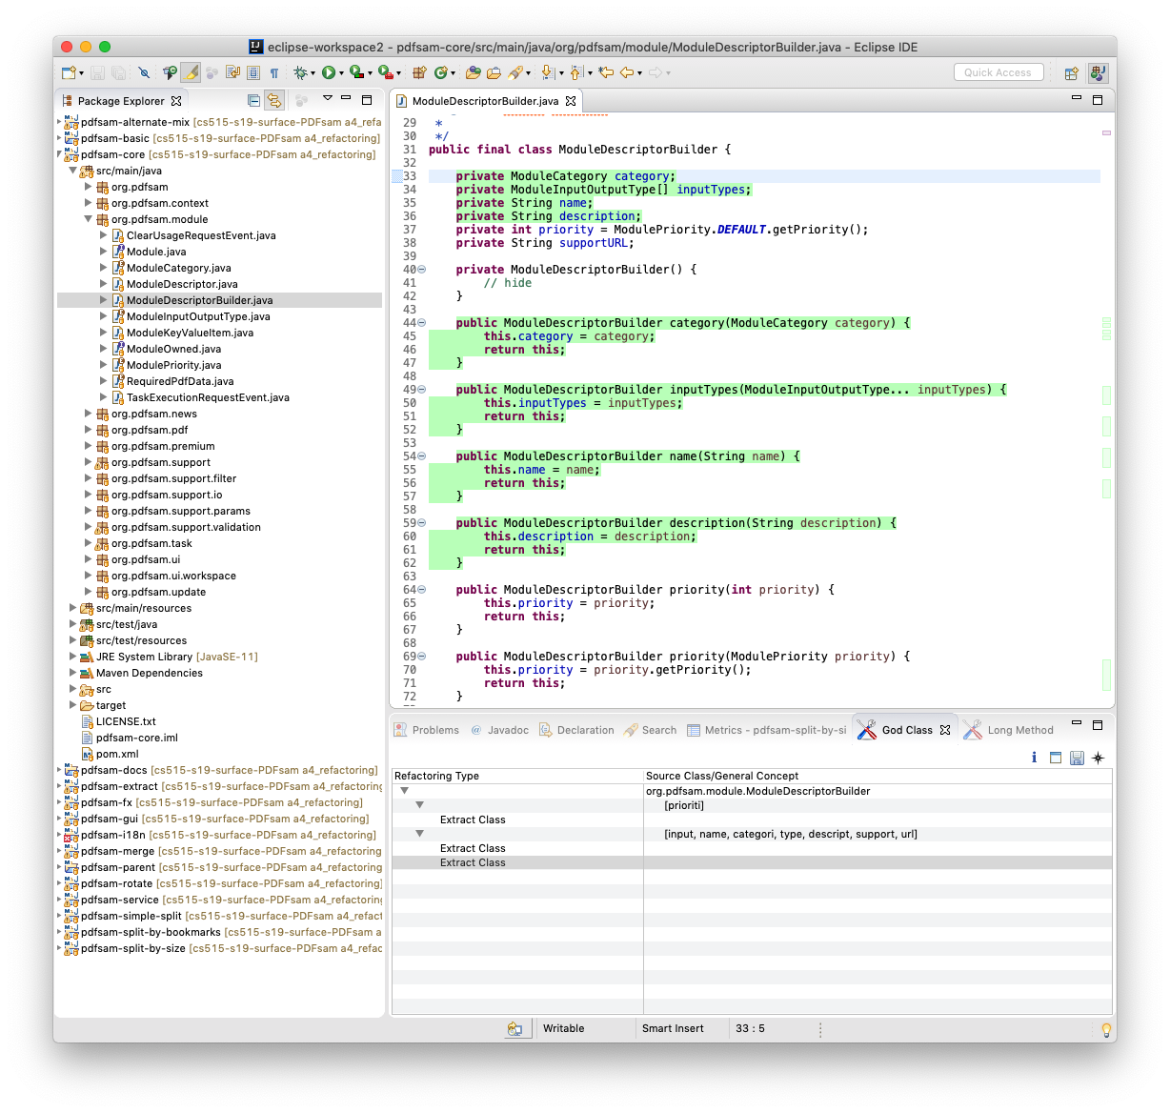

Extract Class

pdfsam-core/src/main/java/org/pdfsam/module/**ModuleDescriptorBuilderData.java**

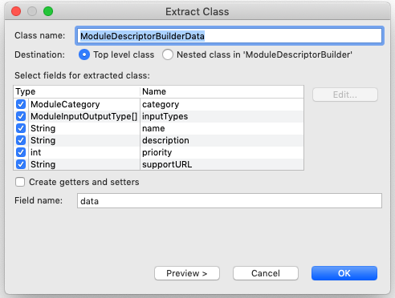

Smell was removed

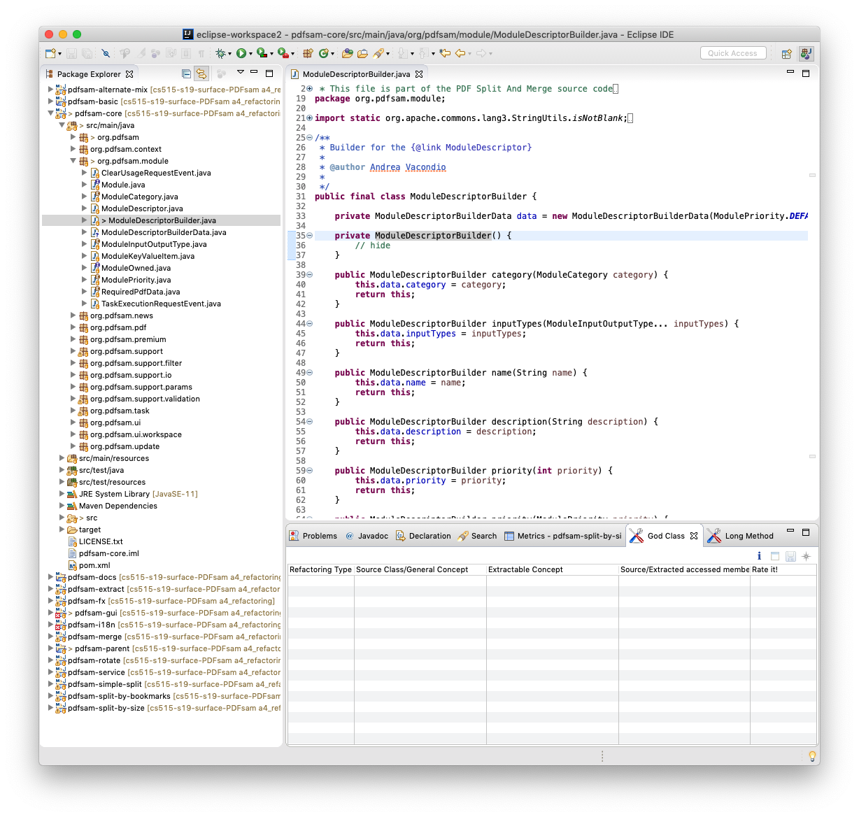

JUnit test was passed



1. Long Method

pdfsam-fx/src/main/java/org/pdfsam/ui/commons/**RadioButtonDrivenTextFieldsPane.java**

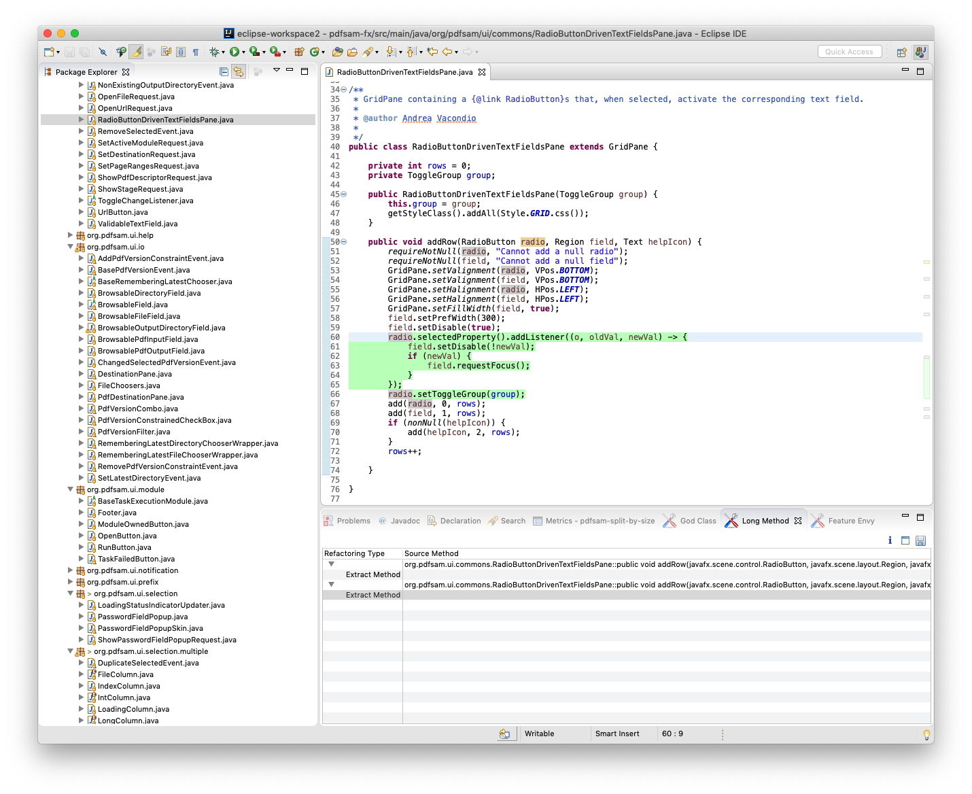

Extract Method

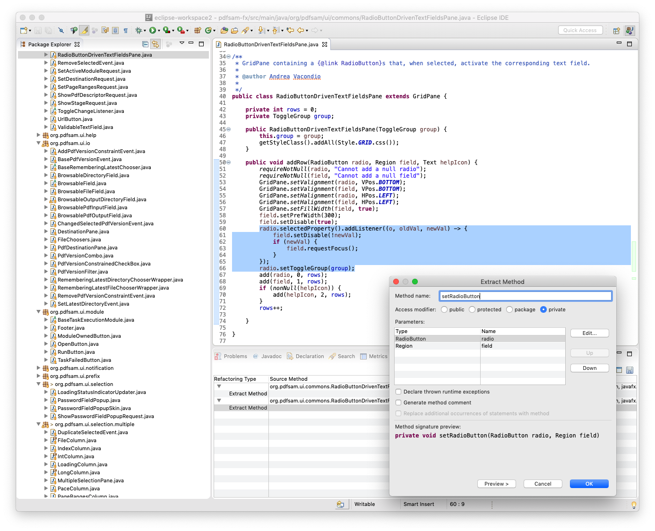

Smell was removed

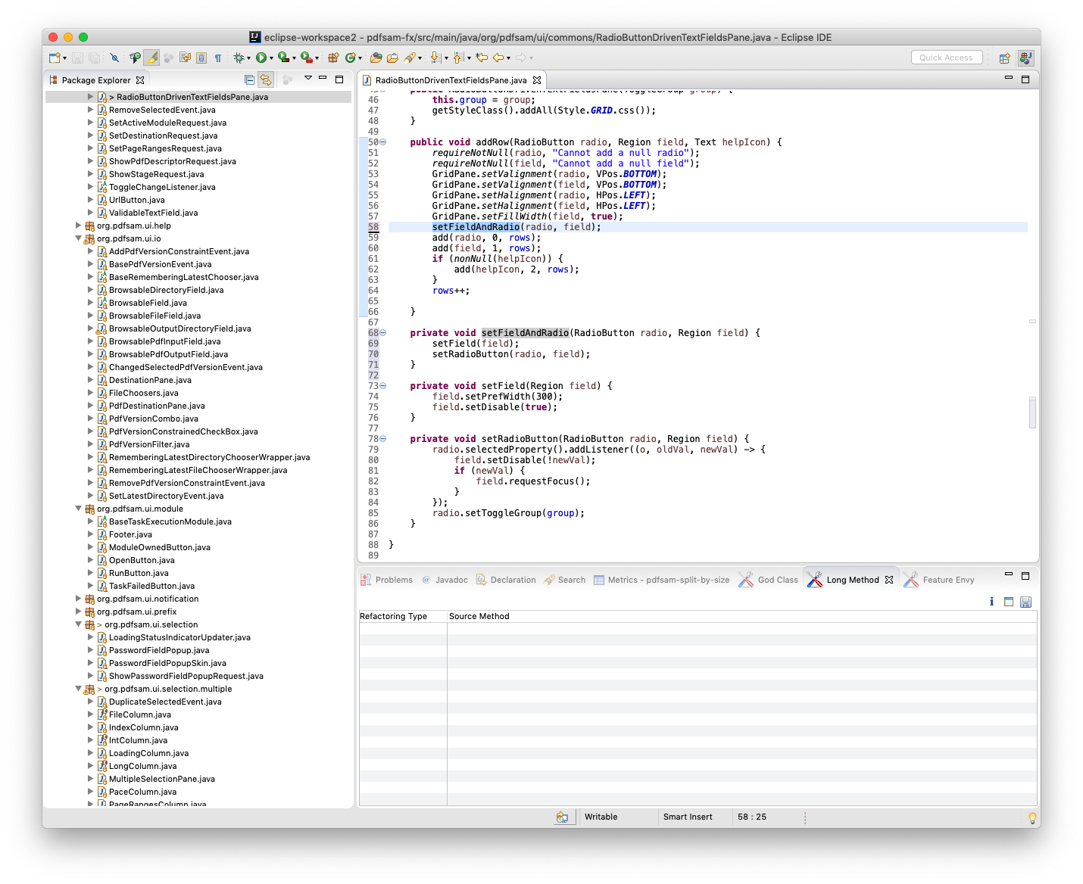

JUnit test was passed

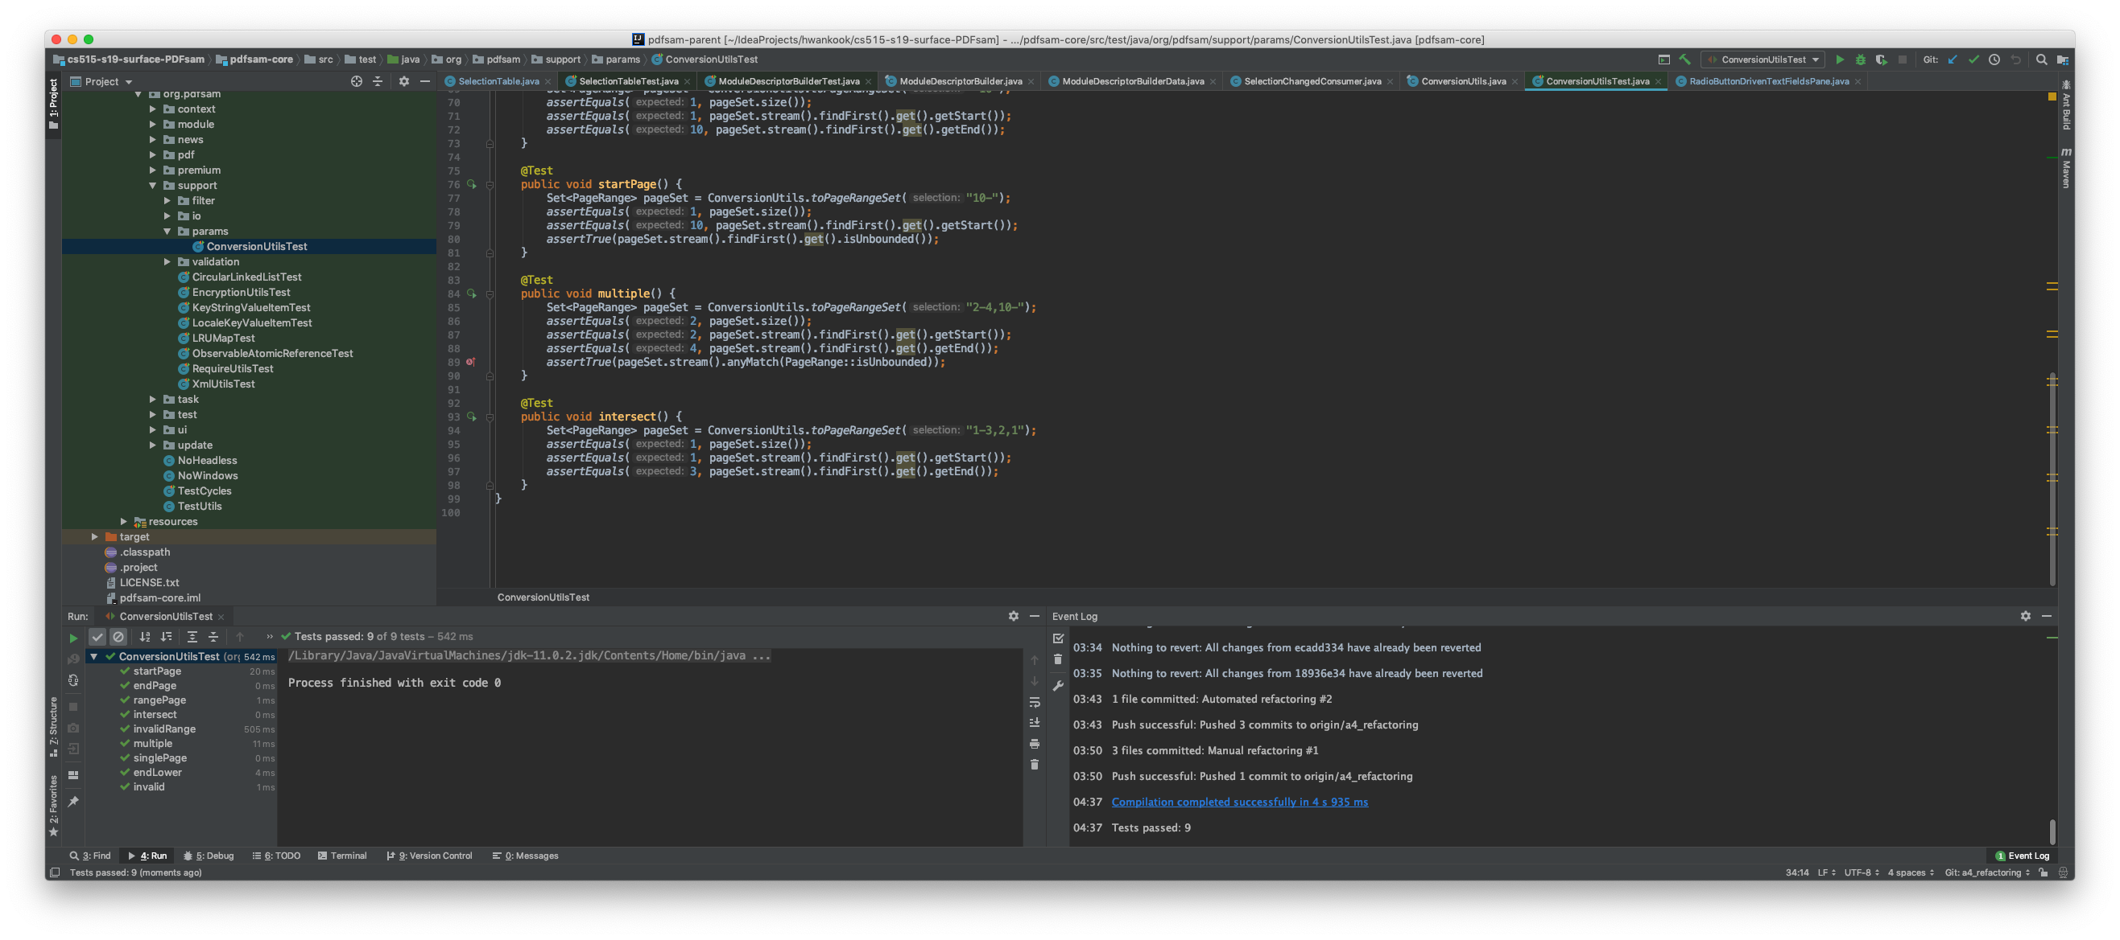

# Manual refactoring

1. God Class

pdfsam-fx/src/main/java/org/pdfsam/ui/selection/multiple/**SelectionTable.java**

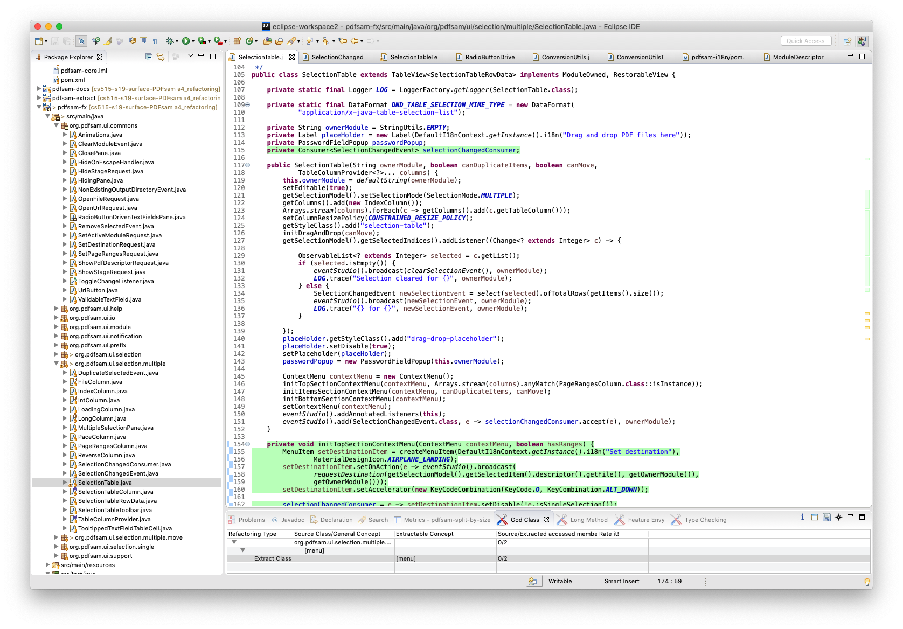

Extract Class

pdfsam-fx/src/main/java/org/pdfsam/ui/selection/multiple/**SelectionChangedConsumer.java**

Smell was removed

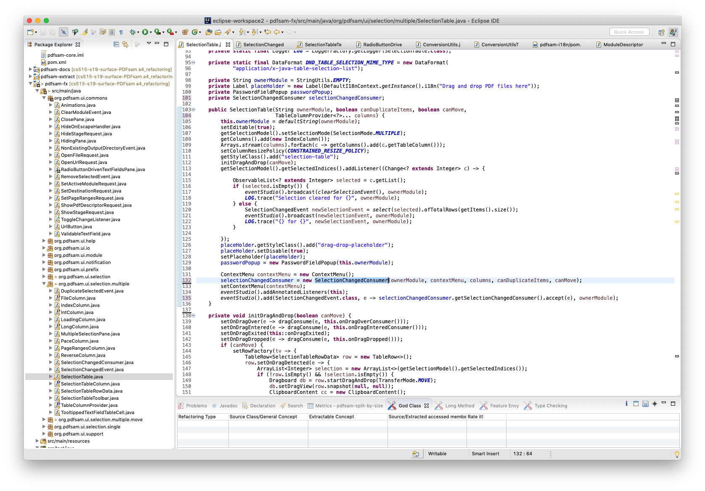

1. Long Method

pdfsam-core/src/main/java/org/pdfsam/support/params/**ConversionUtils.java**

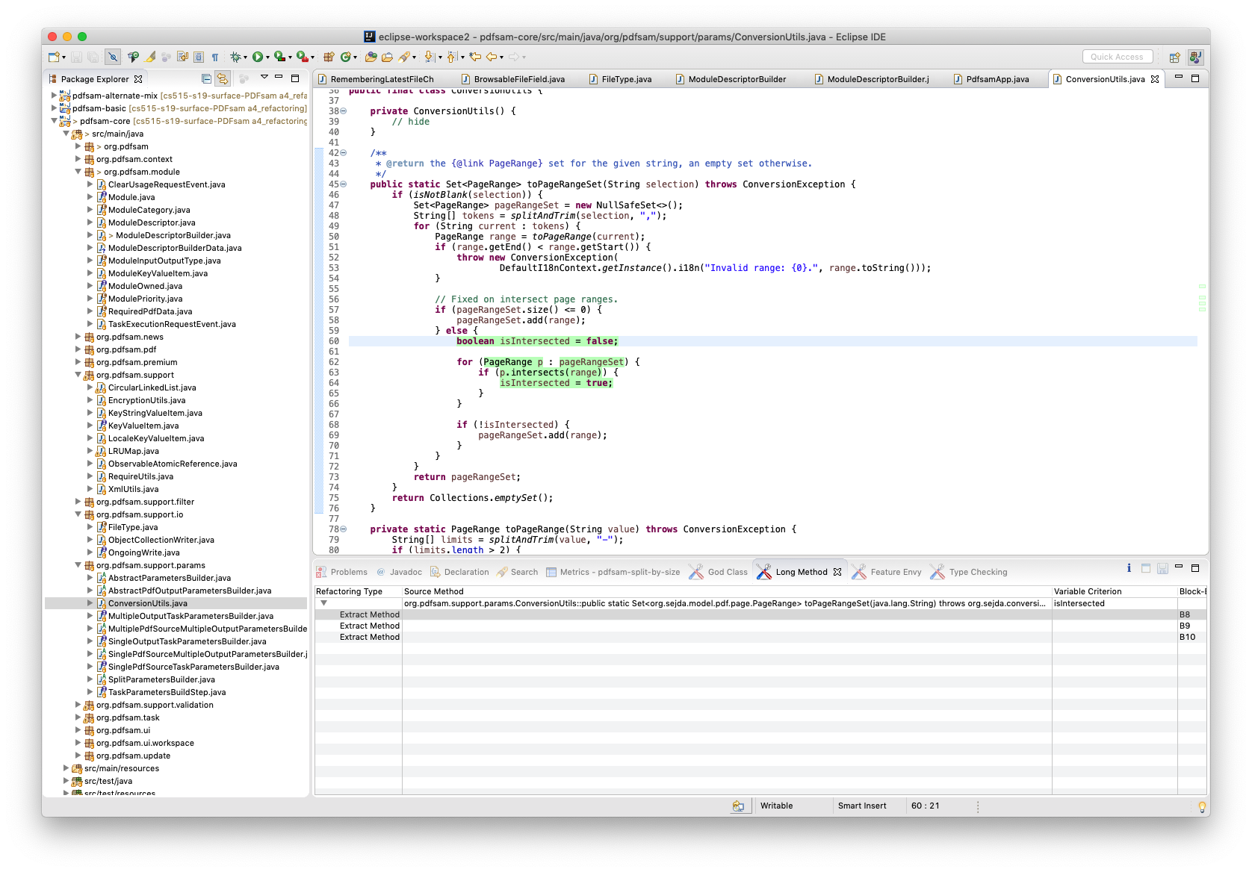

Smell was removed

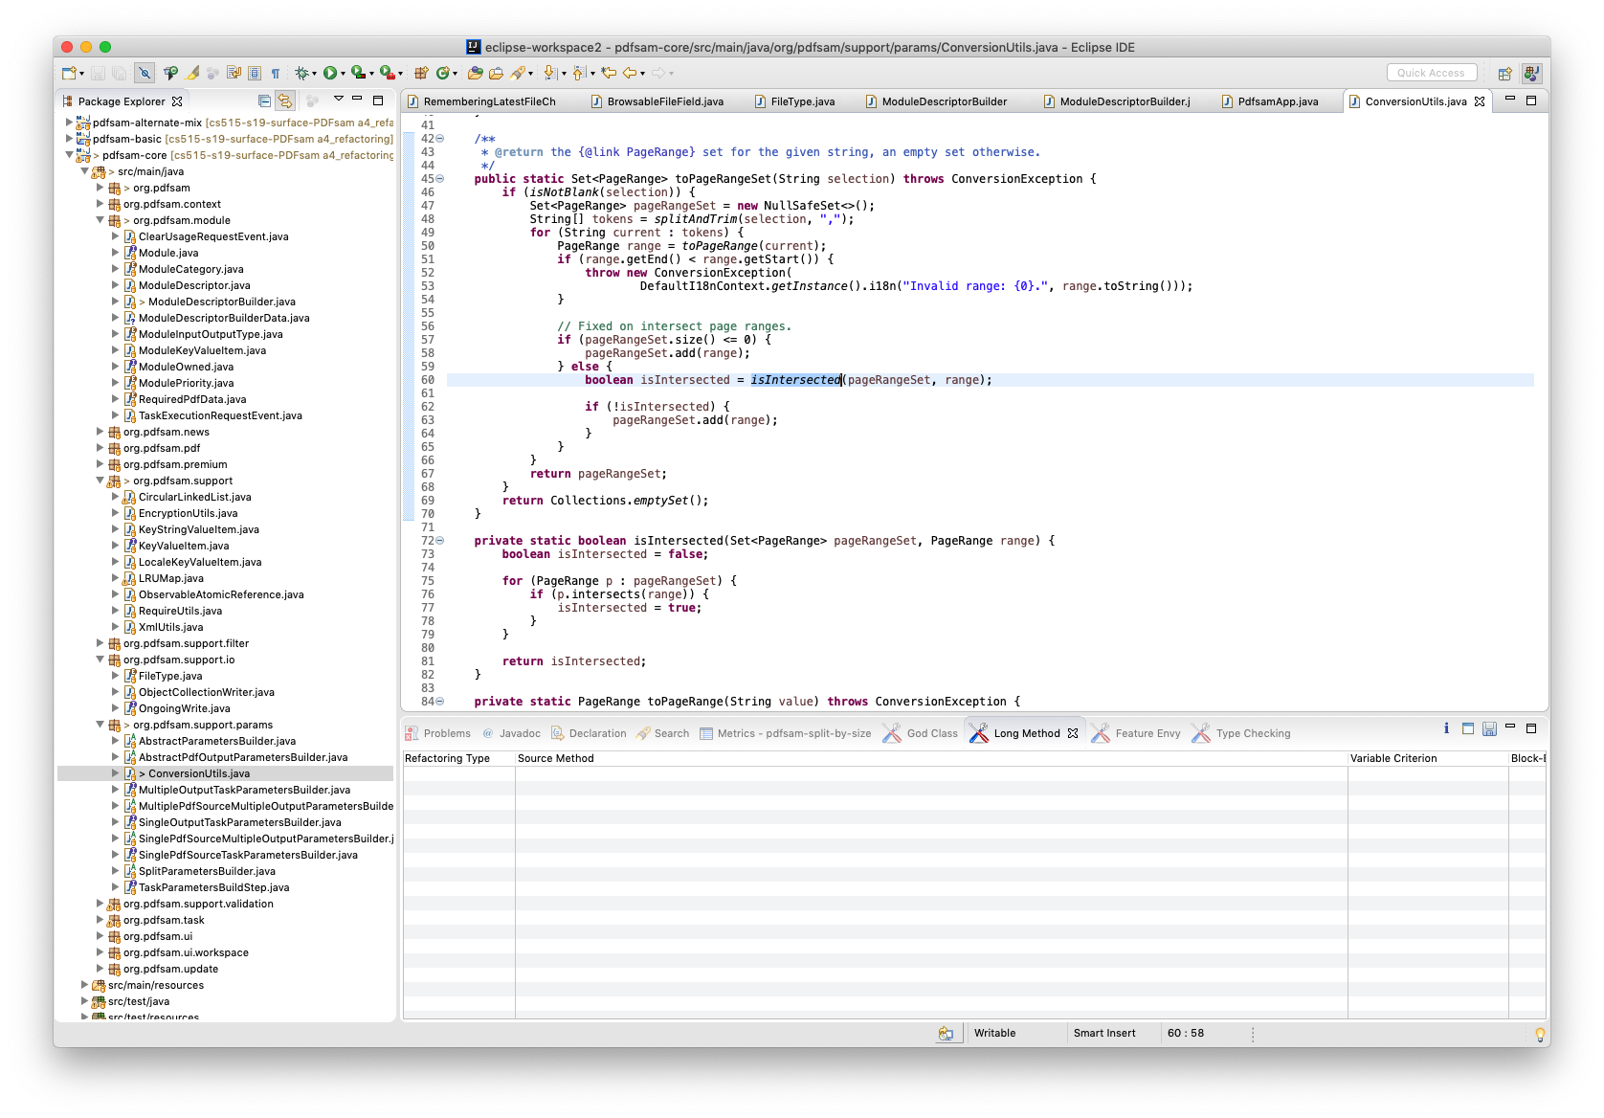

JUnit test was passed

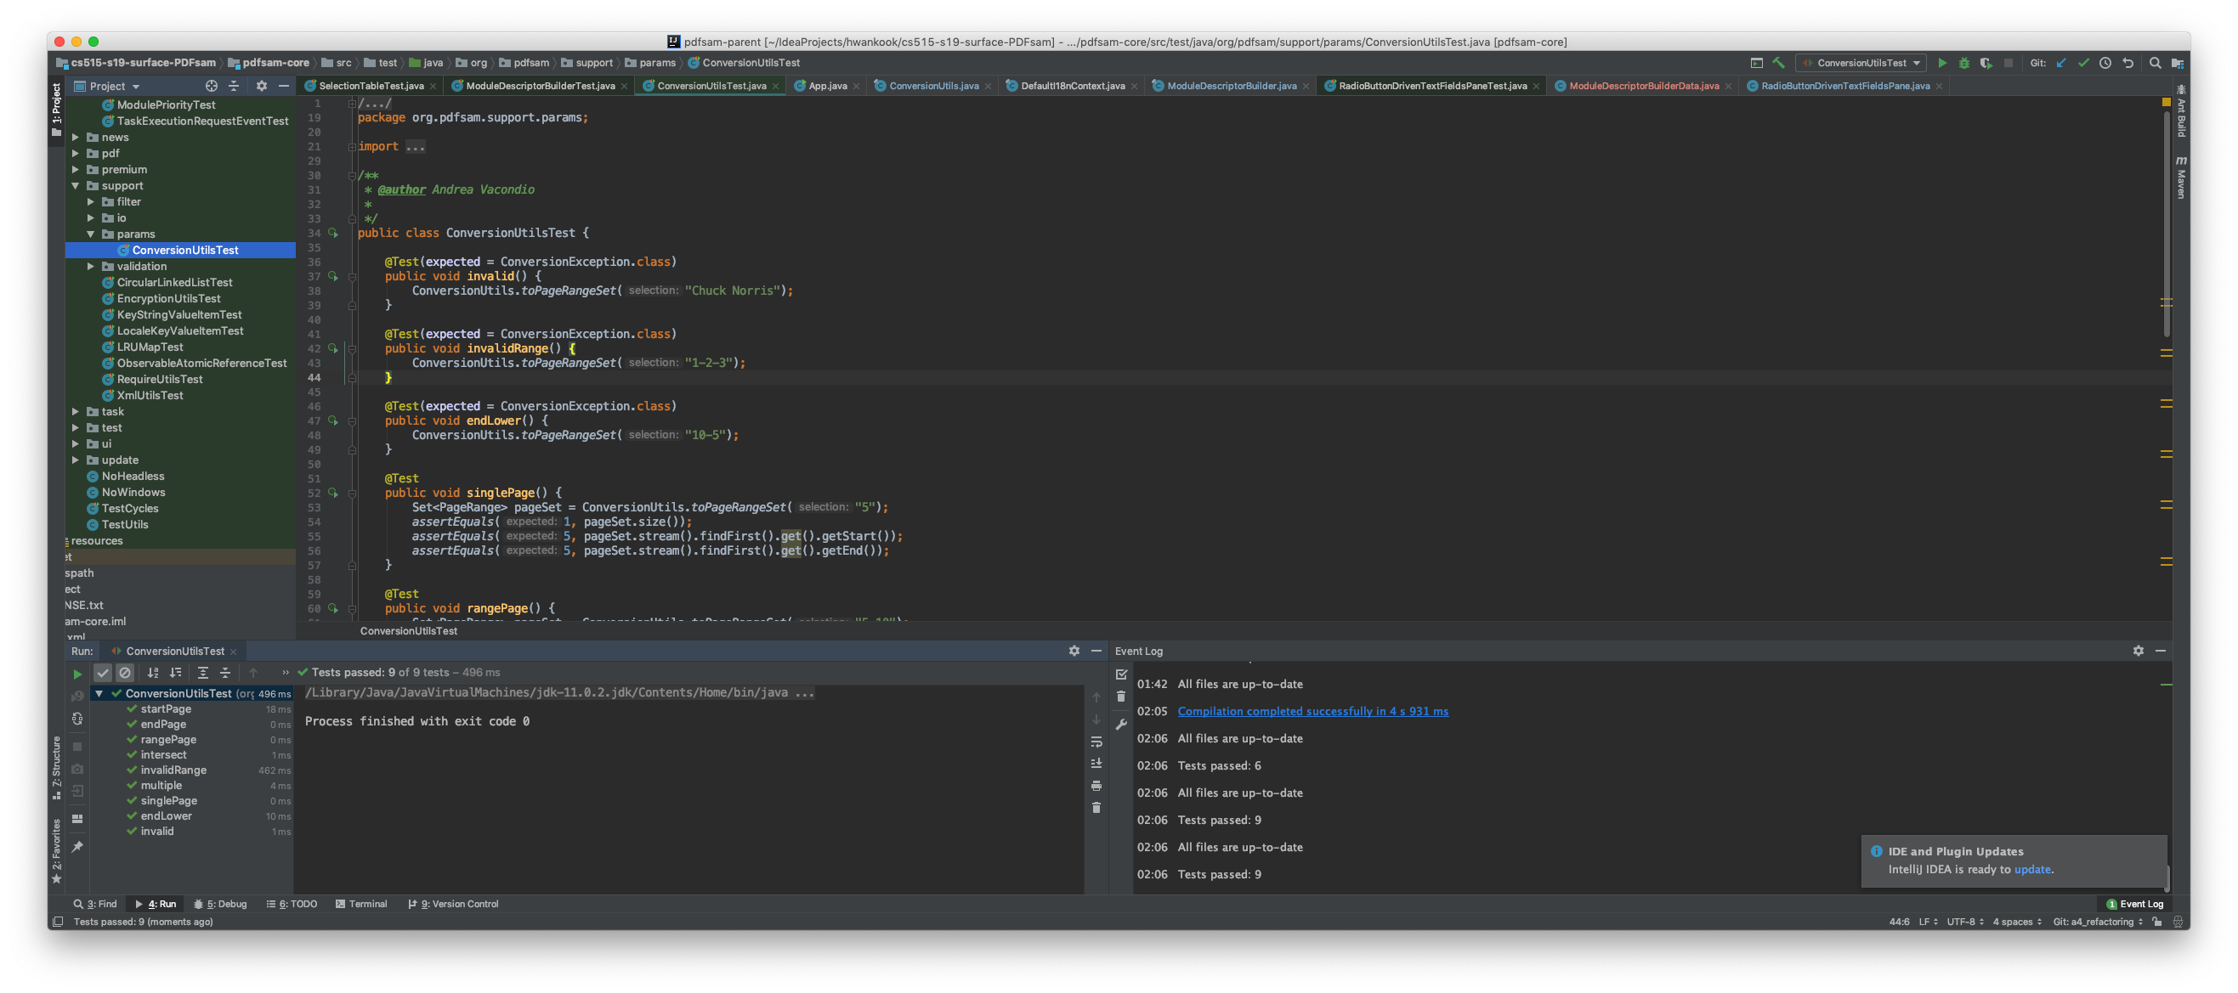

# Refactoring analysis

1. **ModuleDescriptorBuilder.java**

God Class => Extract Class

To remove a code smell of God Class, I used Eclipse’s refactoring functions of extracting Class. From the class, I created a class **ModuleDescriptorBuilderData.java** and then extracted fields from **ModuleDescriptorBuilder.java**.

**RadioButtonDrivenTextFieldsPane.java**

Long Method => Extract Method

In this class, I removed a code smell of Long Method using Eclipse’s extracting method. Detected lines founded by JDeodorant ware moved to a method setFieldAndRadio.

**SelectionTable.java**

God Class => Extract Class

The class clumped together in a lot of methods. The functionalities of class were separated into **SelectionChangedConsumer.java**.

**ConversionUtils.java**

Long Method => Extract Method

I extracted verifying intersected behavior from the class. I made a method isIntersected that functions a verification of intersection.

1. God Class: Looking at **ModuleDescriptorBuilder.java** and **SelectionTable.java**, it is easier to add new features in the existing class than to create a new class. However, when a class has too many functions, it will be tangled with unrelated behaviors. We can encapsulate this class’ fields and methods by extracting class. Extracting class is not only separating data and behavior, but also helping to understand the code.

Long Method: Both **RadioButtonDrivenTextFieldsPane.java** and **ConversionUtils.java** had code that only used once. The extraction a function, however, makes more sense because if I have to spend time into looking at a fragment of code to figure out what it is doing, then I can look at a function of name. That way leads to understand the code easily.

1. Extracting class and method are simply able to use tools, but when it comes to simplifying method calls, simplifying conditional expressions and dealing with generalization are difficult to utilize IDE’s tool since it requires analysis of code. For example, simplifying conditional expressions are complicated in their logic. First, decompose conditional and then replace conditional with polymorphism. This change should lead to the same result or action. Using the IDE’s refactoring tools might help developers to perform their daily tasks of refactoring more effectively, but it is sometimes imprecise, incomplete, and not to be able to use the tool. I used Eclipse that offers Extract Class and Extract Method to remove God Class and Long Method so that it was not difficult to use automated refactoring and convenient.

At first, I would like to remove a smell of Type Checking in SelectionChangedEvent.java although I stated that it was not a code smell in assignment 3. When I tried to alternate code, it was getting to become more difficult to understand code than previous one.